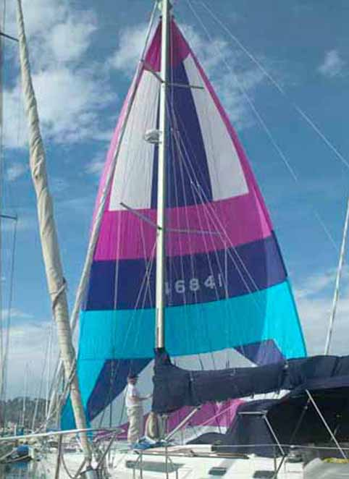
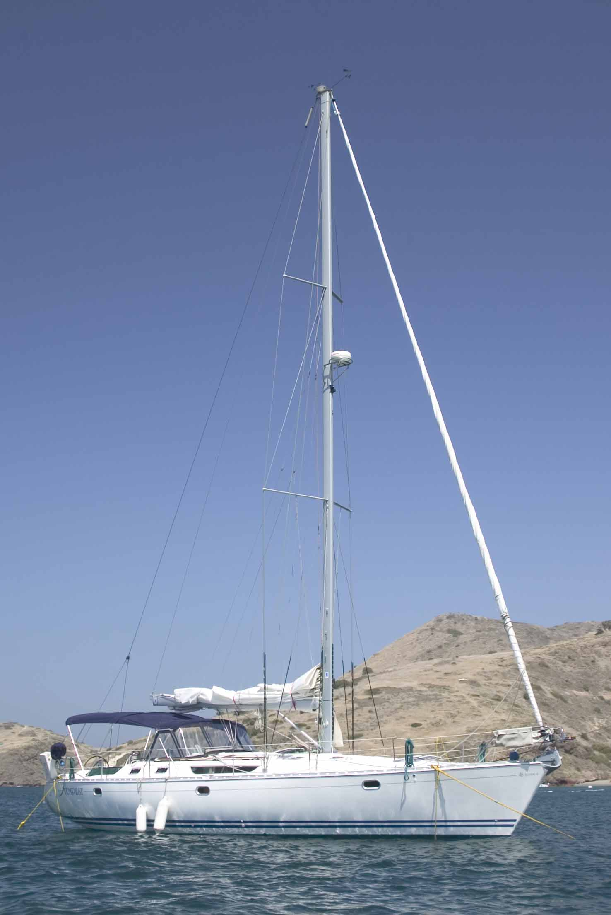
s.v. Tempest
Guest Crew Orientation

For the safety and comfort of guests, each must become familiar with the topics discussed in this document.

PFDs ( PERSONAL FLOATATION DEVICES) – LIFE JACKETS
The vessel is equipped with a more than adequate supply of PFDs. Prior to setting sail, the crew will be assigned his/her personal PFD. Each is numbered. Be certain you become familiar with your PFD and commit its number and location to memory. Also, select the location you feel appropriate and make certain you can retrieve it quickly and easily. If you have any questions on this critical issue, be certain you ask other crew members.

LIFE RAFTS
The vessel has three additional “boats”. The dingy is an eleven foot inflatable Zodiac. When not inflated, it is stowed in the bow (front) stowage locker. In the same place, you’ll find a set of oars in the port-side (left when facing front) rack and a foot pump used to inflate the Zodiac.

Also stowed in the bow locker is an inflatable kayak. Like the dingy, it is inflated with a foot-pump.

In the event of a true emergency where abandonment of ship becomes a real possibility, there is a red package approximately 14” x 16” x 6” stored below the seat on the port side of the cockpit immediately in front of the port side wheel. With the pull of the cord, the package immediately inflates to a four to six person life raft complete with a roof for sun protection, provisions, first-aid supplies and emergency equipment. Please resist the urge to pull the cord unless there is a bonafide emergency. You and all the King’s Horses and all the King’s men will not be able to repackage this rather pricey luxury. If the need to view it is overwhelming, ask and we’ll be happy to provide you with a picture.

EPIRBs
In the unlikely event of a major problem at sea, The Tempest is equipped with three EPIRBs (Emergency Position Indicating Radio Beacon). These devices communicate directly with a satellite and when activated provide rescuers rapid access to our position. There is one device attached to the boat itself and two “personal” EPIRBs. In the event rescue is legitimately required, activate the devices as shown on the body of each. Also realize that in the case of abandonment of ship, if one of the personal EPIRBs isn’t brought with us, the rescuers will quickly find the remnants of our boat, but have to guess where we went.

DO NOT ACTIVATE THESE DEVICES JUST TO SEE THEM WORK. IF YOU DO, YOU WILL NOT ONLY LEARN THEY WORK VERY WELL, BUT WILL ALSO LEARN A GREAT DEAL MORE ABOUT THE SIZE OF THE FINES AND PUNISHMENTS ASSESSED FOR IMPROPER USE.

LIGHT SWITCHES
One of the more entertaining challenges for the new crew member is to locate light switches onboard. We suggest you familiarize yourself with their location shortly after boarding. Maintenance costs on a sailing vessel such as The Tempest are high enough without the cost of removing blood and body parts from furniture and fixtures after someone tries to maneuver through the boat to the head (bathroom) in the middle of the night. There are ample tripping hazards in the daylight. No need to compound the problem at night. This leads us to the next topic . . .

FIRST AID
The Tempest is equipped with two first aid kits (in addition to the normal supply of band aids, aspirin, etc.) One is a very extensive compilation of first aid and medical tools. The other is better and probably suited to perform open-heart surgery and knee replacements. However, be advised the only medical procedures in which the Captain has training (after grade school that is) involves the use of a gourd rattle. Unfortunately, neither kit contains one. Hence, familiarize yourself with the location of the first aid kits or be prepared to scream for help when injured and hope a crew member with knowledge of the location of the medical kits is within hearing distance.

TRIPPING AND OVERHEAD HAZARDS
Sailing vessels are different than houses (except in southern Mississippi). There are bulkheads, structural supports, foot-pumps, protrusions, extensions, levers, controls, hoses, lines, sheets, blocks, winches, bimminis and dodgers strategically placed to get you when you’re not looking. We have found that after breaking a toe or two, you begin to commit the location of these things to memory. However, you may find your sailing experience to be a bit more pleasurable if you survey your surroundings ahead of time and make a mental note as to the location of some of these hazards. If you are not vertically-challenged, make a special survey of the layout of the deckhead (ceiling) of the guest cabins. Many have looked at the level of one section while hammering their heads on the lower adjacent section.

FINGERS – EXTREME DANGER
Sailing is normally viewed as a serene and relaxing activity and indeed with proper care, it should be so. However, there are many very serious dangers lurking throughout the boat. One of the most series hazards involves crushed and even lost fingers. Become very aware of the following dangers.

In some situations, it may be necessary to “fend off” a pier, dock or even another vessel. Inexperienced sailors need to be aware that even though we may be moving extremely slowly, the boat is rated at twenty-seven tons. This means that if you have your fingers between the boat railing and an object that we impact even very lightly, you risk losing fingers. For this reason, NEVER get your fingers (or other body parts) between another object and the boat if contact is possible. The boat will no doubt survive. Your fingers will not. We recommend counting your fingers before boarding and making every effort to leave with the same number of fingers.

There are two “boat-hooks” or “fending poles” generally laying top-side under the dodger.

FINGERS – MORE DANGER
A sailing vessel has innumerable lines (ropes). Many of these lines are under extreme tension, especially while sailing. Although they may appear to be stable and unmoving, the release of a clutch or engagement of a winch can cause them to move quickly and with tremendous forces. Fingers can easily be lost if sailors are not extremely vigilant and cautious. Also be aware that the sudden release of a line while it is being held can cause extreme rope-burns. Use extreme caution when handling lines while on-board.

MOVING ABOUT ABOVE BOARD
It is highly recommended that prior to arrival, you acquire “non-marking” shoes for use while on The Tempest. Out of the cockpit and onto deck areas, it is no longer a recommendation; it is a requirement. If you do not have non-marking deck shoes of some kind, you will be asked to wear your “poor man’s deck-shoes”, i.e., go barefoot onto the deck areas. This is a romantic approach to sailing until you discover one of the many toe-stubbing hazards on deck. If you do this well, you can even parlay this experience into a man-overboard event at the same time.

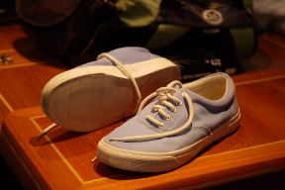
Non-marking deck-shoes come in fundamentally two types. The inexpensive canvas topped sneaker type shoes (I recently purchased a pair at Nordstroms for $20) and the “cool yacht man” style that look like loafers (which coincidentally are what many yacht people look like). They (the shoes – not the yacht people) cost from $40 to $300. We have found very nice pairs for $70-$80 at boating stores such as West Marine or Nordstroms. Be sure to look “cool” when asking for them at Nordstroms. Tell them you need them for the club in Monaco.

Note that “non-marking” is not the same thing as “soft-soled” shoes. Tennis shoes are generally NOT non-marking. White bottoms do not mean non-marking and black bottoms no not necessarily mean marking.

HEADS (BATHROOMS)
Even though The Tempest is by sailing standards, a “roomy” boat with a nearly 15 foot beam (width), space is at a premium. You’ll find the heads are “cozy” and designed to maximize space utilization. One of the features you’ll learn to love is the marine commode. The first thing you need to master is “flushing” it.

Prior to using it, make sure there’s a water seal in it (this is not to be confused with a marine animal which once on board is very difficult to remove). You will find a small lever on the left side of the device. When moved to the left-hand position, it will pump salt-water into the commode when you gently pump the adjacent handle. With continued pumping, it will also drain the salt-water as it adds salt-water. In other words, you may “clean” the commode with this technique and generally not have to worry about over-filling it with salt-water. This technique can also be very useful at night as a source of entertainment, especially for those of you that lived through the sixties or early seventies or have ever attended a Grateful Dead concert – see the historical note below.

With your water seal in place, feel free to indulge yourself as you see fit. Upon completion of your task, place the lever to the right. This puts the commode into the “rapid removal” mode. Pump the handle until your work of art has disappeared. Then flip the lever back to the left-hand position and re-establish the water seal.

DO NOT throw foreign objects into the commode; it is not a trash receptacle. (We realize that the boat spends a great deal of time in foreign countries and that this statement begs for semantic clarification, however, we’re hoping you get the point.)

WASTE CONTROL
The matter of waste control is a serious issue, especially to the U.S. Coast Guard officer that will be making the arrest after you violate one of the related laws. Suffice it to say, the following two statements summarize the waste control policies when onboard The Tempest.

- If in doubt, don’t throw it, pour it, dump it, flush it, fling it or otherwise dispose of it overboard.
- If not in doubt, don’t throw it, pour it, dump it, flush it, fling it or otherwise dispose of it overboard.

There are strict rules regarding the disposal of waste in U.S. as well as in international waters. A more formal outline of these rules is posted on the wall in the galley area of the boat and at the base of the companionway (the stairway leading into the salon (living room)).

A couple of the more important ones to be aware of are:

- Human waste may not be discharged into the waters unless you are three or more miles from shore.
- Plastic may not be cast into the waters at any time period – even if you are a thousand miles from shore. This is by international treaty. If you violate this law, a missile strike will be instantly launched upon you (by the captain of the vessel).

Also please take advantage of the fact that when in a marina, we always have access to bathroom and shower facilities in the marina itself. This keeps the “holding tanks” on the vessel from filling and eliminates the need to store large quantities of materials we’re normally trying to get rid of on the boat. It also means we don’t have to pay someone to come and pump the holding tanks after they’ve over-filled in the middle of the night. (It also gives you an opportunity to meet nice people in a semi-public restroom – like the guy we met wearing a raincoat and having a rubber-ducky on his head).

VENTILATION
The Tempest is equipped with numerous hatches. When sleeping in your cabins during periods of cold weather, you will find it is wise to open a hatch or two for ventilation. Although this may seem contrary to the efforts to keep the boat warm at night, it will make your sleeping experience more pleasurable and less exciting. In humid climates, the combination of a warm interior and cold exterior results in a significant amount of condensation. Cracking a hatch open allows the moisture from breathing, etc., to escape. If you fail to do this, you will gain a greater appreciation for the procedure at about 3 a.m. when the ice-water from condensing vapors begins to fall upon your heretofore warm and toasty body.

Note that it is also wise to close the hatches upon waking in the morning. It can be more than annoying to everyone when someone hurries across the deck to secure the halyard and suddenly disappears into the aft-head.

ALL HATCHES MUST BE SECURELY CLOSED WHEN AT SEA. FAILURE TO DO SO CAN HAVE DIRE CONSEQUENCES AND AN OPPORTUNITY TO MEET DAVEY JONES PERSONALLY.

HANDLING THE WHEEL – AUTOPILOT
In most cases during sea passages, the ship is running on autopilot. This means the steering of the vessel is being computer controlled. If you’re a guest crew member, we encourage you to get the most out of your experience and to chip in with the chores including the steering of the boat. Actually we look forward to having our guests do all the work, but we’ve yet to master this selling job.

It is IMPORTANT to know that if you’re asked to take control at the wheel (or if the urge is just too great to suppress), DO NOT ATTEMPT TO STEER THE VESSEL WITHOUT DISABLING THE AUTOPILOT. The autopilot control panel is immediately to the right of the starboard wheel and immediately to the left of the port wheel. Just press the button labeled “STAND-BY” and you take control of the boat. Pressing the “AUTOPILOT” button puts the boat back on autopilot on whatever heading you’re at when the button is pressed.

Kindly refrain from taking the boat off of autopilot and then leaving the helm. This amounts to becoming a “ship without a rudder” and even though you probably know this as a bad thing in most metaphors, it is really a bad thing on a boat.

CONSERVATION – WATER AND ELECTRICITY
When fully provisioned, the Tempest can remain at sea for months at a time without stopping in port. She is equipped with a 600 gallon per day water making system, an 8 KW electric generator, solar power, refrigerator, freezer, propane fueled galley, the latest in navigation equipment, radios, etc., however, she is not the international space station. Resources are finite. When not in a marina, it is important that you keep this in mind. Please be energy and resource conscious. Turn out lights when they’re not required. Use our fresh water supply sparingly; trust me – your hair looks just fine. We have a salt-water rinse for dish washing. Take advantage of it when at sea for lengthy time periods.

MAN OVERBOARD
If someone falls overboard, immediate action is critical to the success of the rescue operation (unless this person voted for Bush). Someone must maintain eye contact with the person overboard. If that person is you, DO NOT leave your position. Call for help, but watch the location of the person overboard.

As soon as possible, press one of the “MOB” buttons near the ship’s wheels. This places a GPS waypoint in the ship’s navigational computer system.

Then immediately remove the man-overboard pole from its mount on the starboard side of the boat. Get it into the water as quickly as possible and as close to the person overboard as possible. Open the cover of the MOB life-ring, in the white, plaster container located on the starboard rail next to the wheel. Feed out the line as quickly as possible.

Finally, take whatever steps are necessary to maneuver the boat back toward the person overboard. If the engine is running, feather the prop as you approach the person.

KNOTS
There are complete books dedicated solely to the art of knot-tying. If you are a land-lubber and unfamiliar with the basic knots of sailing, rest easy with the knowledge you can get by quite well as a guest crew member by knowing only two – the bowline (pronounced “bo – linn” with a long “o”) and the way a dock-line is tied off to a cleat (actually this isn’t a knot – it’s a hitch; if you’re a mountain climber, you already knew this). If you’d like instructions on either of these, you need only ask a crew member. We even have lengths of line onboard for you to practice.
PACKING FOR YOUR TRIP
Compared with the average sailing vessel, The Tempest is a large and roomy boat. However, it is not a cruise ship. Your luggage will not mysteriously appear in your cabin nor will it magically disappear as one of the cadre of Philippino porters hauls it into the bowels of the boat to be stored with the banquet tables and karaoke equipment. There is no convenient location to store large, hard-shelled luggage. If you are driving to the boat and leaving a car in port, you may unpack then remove your luggage to shore and lock it in your vehicle. You can arrange for storage at a marina. You may dig a hole and bury it. You may throw it overboard. However, you may not store it on the boat.

For this reason, it is to your advantage to pack your things in a collapsible duffel. Some of our more style conscious guests have actually used plastic garbage-bags.

Note also that when in port, we generally have access to laundry facilities. In Ensenada, Mexico, the laundry is actually done for us (this luxury is way too easy to get used to – you may want to do your own laundry just to stay in shape). The point is this – you do not need bring a separate color-coordinated outfit for each and every day and evening of your visit. When climbing big mountains, the serious alpinist is just getting his shorts broken in by about day five. You will probably survive a wrinkle or two in your ascot.

If you’re visiting the Tempest while she is in Southern California or somewhere in Mexico and you’re coming from a colder climate, you may be inclined to assume all that is required is a bikini bottom and sunglasses, you may be in for a rude awakening. Mexico – the land of the hot chili – can be cold. In the winter months, a light, lined jacket will almost assuredly be required, especially in the early mornings. A hooded sweatshirt and a light pair of gloves may be a pleasant luxury at times. A pair of “shower sandals” or thongs (for your feet) may be nice when using marina facilities.

Also note that when out to sea, it can be cold. Be prepared.

CELL PHONES AND INTERNET
Although they don’t officially acknowledge it, I have pretty good luck using my Verizon cell phone in Ensenada, Mazatlan, Puerto Vallarta, and other cities in Mexico. If you have Verizon, I suggest pressing “*228” prior to leaving the United States. This updates your roaming and seems to make it work fine in Mexican cities. This doesn’t help pay the bill however. Additional roaming charges undoubtedly will apply. Also note that if someone calls and leaves voicemail, you will not get notice on your cell phone that you have voicemail until you cross back into the United States.

For non-Verizon customers, contact your provider for instructions (even though I’ve almost never had any of them give me the correct ones).

When in port, especially in Mexico, internet cafes generally abound. Wireless “hot-spots” are becoming very common, even in Mexico. When in nearly all U.S. ports and their surroundings (including Catalina Island), we usually have internet access on the boat.

The Tempest is equipped with a satellite telephone and internet service. As such, we have standard telephone service anywhere and everywhere in the world. We also have full time internet access anywhere in the world. However, it is “standard” only when you don’t take into account the cost of making calls. If you wish to leave the phone number for someone, let them know the following international call number and that depending upon their phone service provider, it could cost the caller as much as $8 - $12 per minute. Needless to say, no one will be calling without a good reason. S.V. Tempest phone: 011-870-764-576-268. (If you have trouble getting through on this number, try 011-872-764-576-268.)

